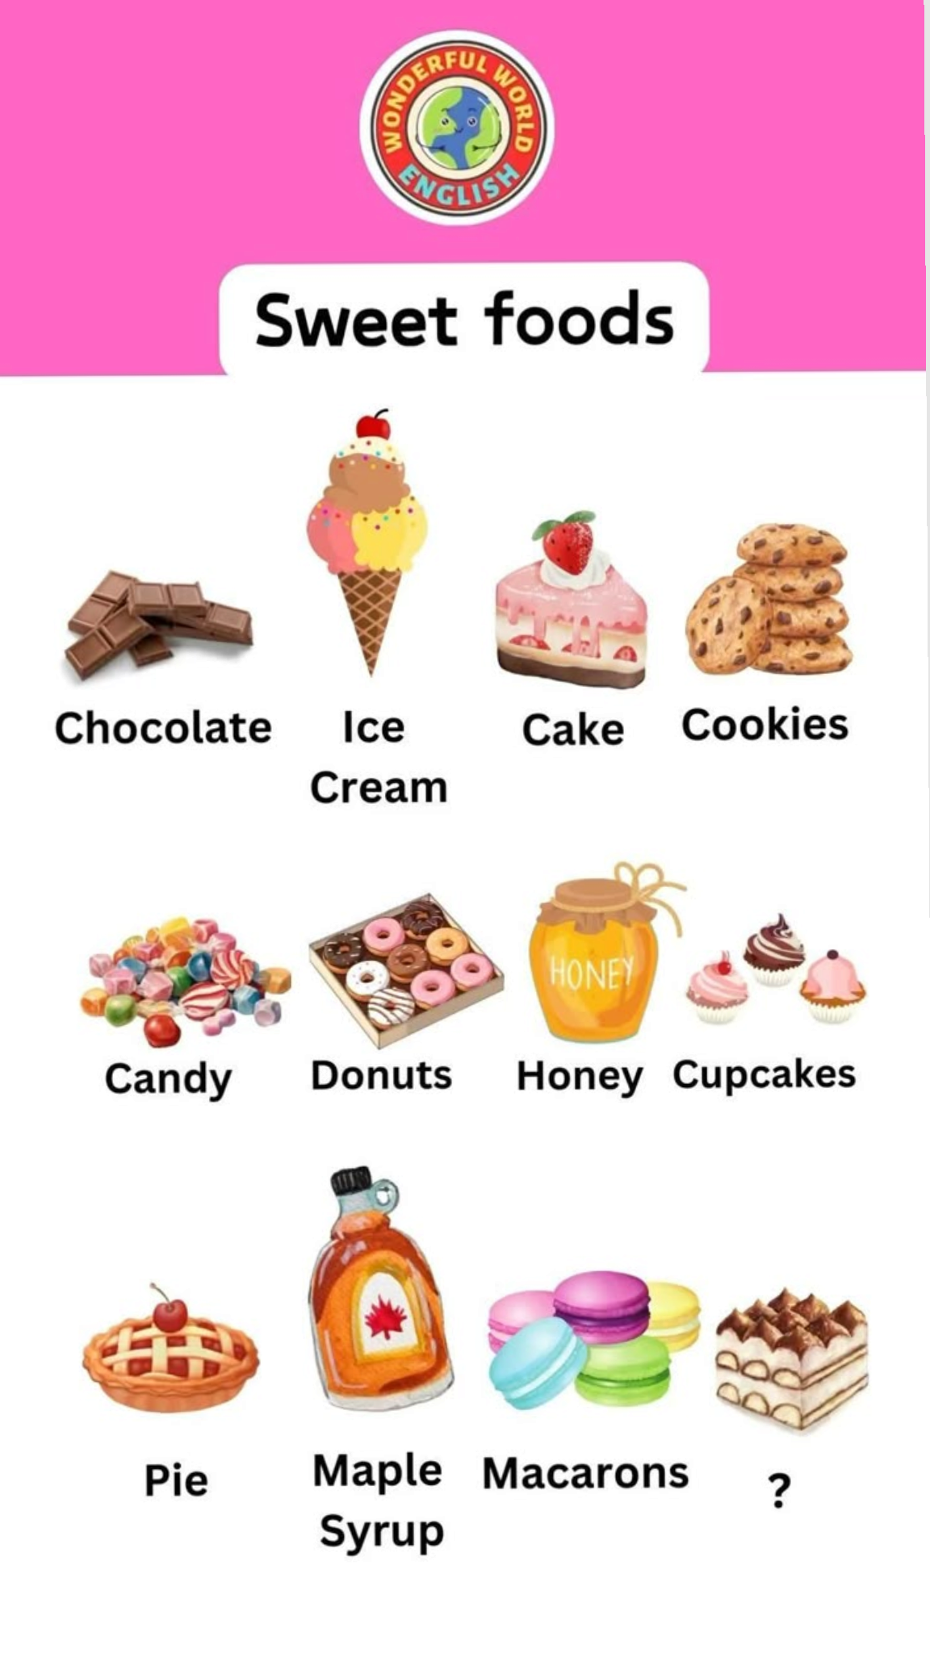
SWEET FOODS IMAGES

